Experiment No: 7
Name: Atharva Salitri
Year & Branch: TY-CSAI-B
Batch: 2
Roll no: 29
PRN: 12310120
Subject: Cloud Computing

To Explore Cloud Services:
AWS:
To create AWS account and use S3 storage bucket

Procedure for Managing Data in Amazon S3
Amazon S3 is an object storage service that offers industry-leading scalability, data availability, security, and performance. It allows users to store and protect any amount of data for a range of use cases, such as data lakes, websites, cloud-native applications, backups, archives, machine learning, and analytics.
The AWS Free Tier for Amazon S3 includes the following for up to 12 months:
- 5 GB of S3 Standard storage
- 20,000 Get Requests
- 2,000 Put, Copy, Post, or List Requests

1. Create an S3 Bucket
A bucket is a container for objects stored in Amazon S3.
a. Sign in to the AWS Management Console and open the Amazon S3 console at https://console.aws.amazon.com/s3/.
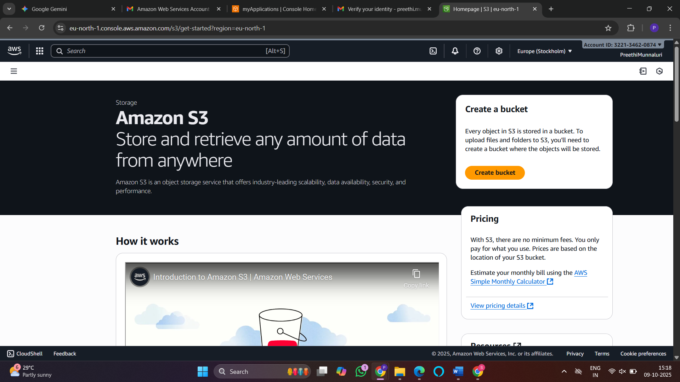

b. In the left navigation pane, choose Buckets.
c. Choose Create bucket. The Create bucket page will open.
d. For Bucket name, enter a unique name for your bucket, following the required naming conventions. Note: The bucket name cannot be changed after creation.
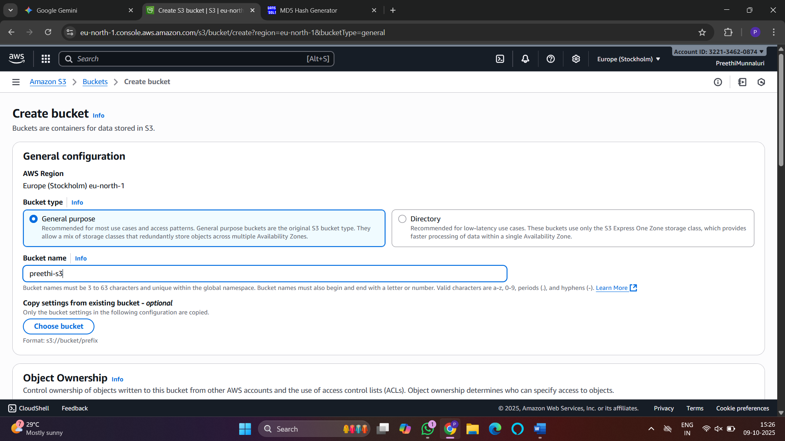
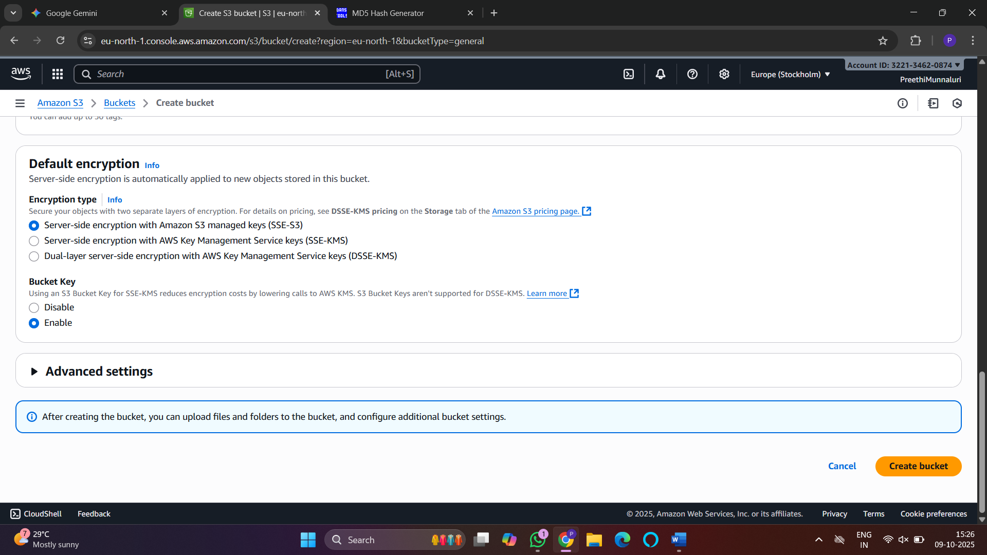
e. Select an AWS Region where you want the bucket to reside.
f. You may use an existing bucket's configuration by selecting the Choose bucket option.
g. Choose Create bucket to finalize.
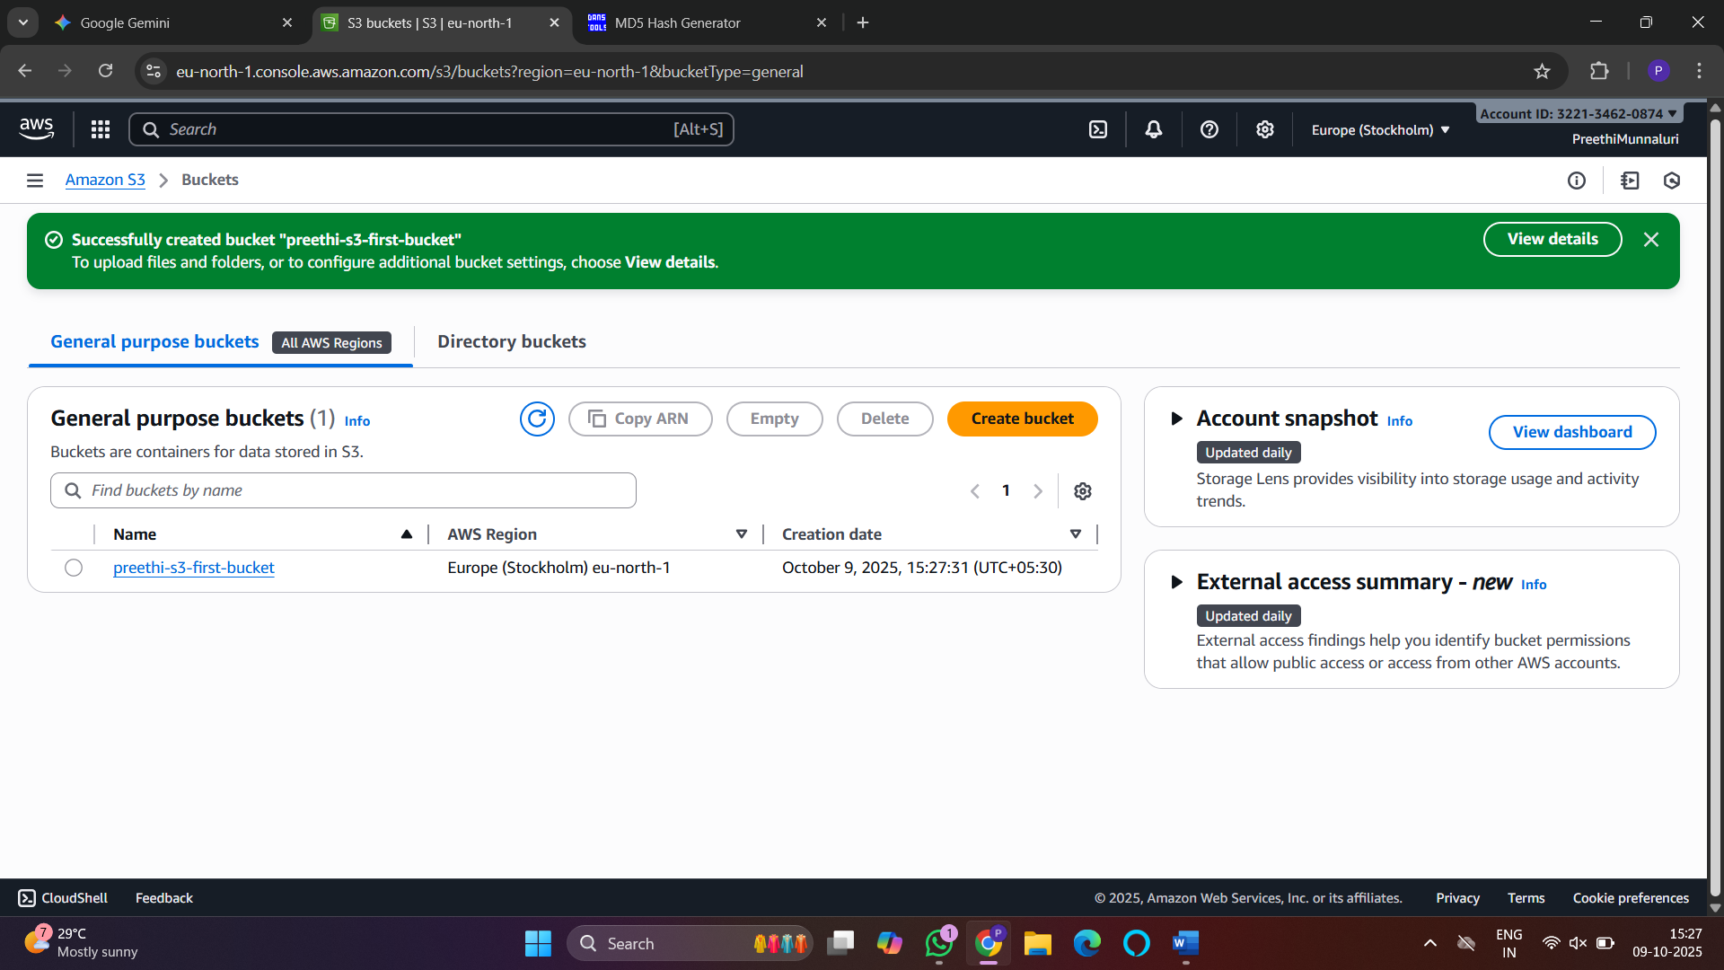
Bucket Naming Conventions
The bucket name must:
- Be unique across all of AWS.
- Be between 3 and 63 characters long.
- Consist only of lowercase letters, numbers, dots (.), and hyphens (-).
- Begin and end with a letter or number.

2. Upload an Object to a Bucket
Follow these steps to upload files (objects) into your newly created bucket.
a. Open the Amazon S3 console.
b. In the Buckets list, choose the name of the destination bucket.
c. On the Objects tab, choose Upload.
d. Under the Files and folders section, choose Add files.
e. Select the file you wish to upload from your local machine and choose Open.
f. Choose Upload to begin the transfer. The file's size and properties will be displayed after a successful upload.
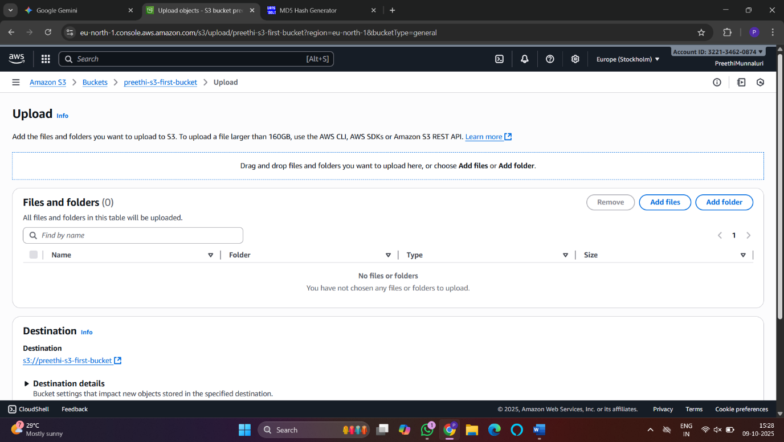
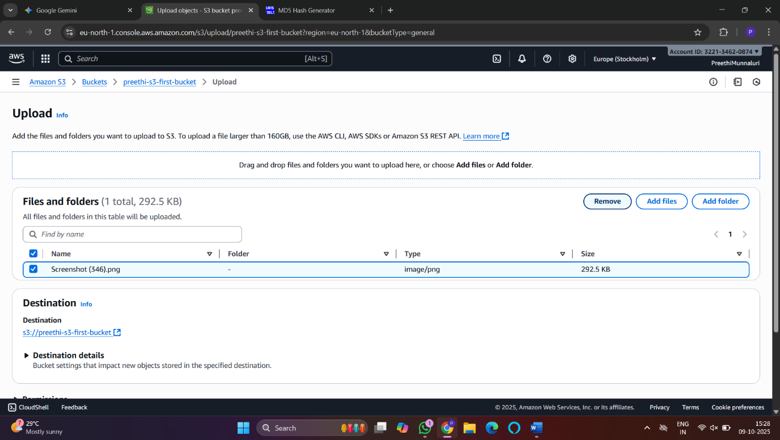

3. Delete an Object from a Bucket
You can delete individual objects from a bucket without emptying the entire bucket.
a. In the Buckets list, choose the name of the bucket containing the object.
b. Select the checkbox next to the object(s) you want to delete.
c. Choose Delete from the actions menu in the upper right.
d. On the Delete objects page, type delete into the text field to confirm the action.
e. Choose Delete objects.

4. Empty and Delete a Bucket
To delete a bucket, it must first be empty.
a. Empty the Bucket
This action permanently deletes all objects within the bucket.
- In the Buckets list, select the bucket you want to empty.
- Choose Empty.
- On the Empty bucket page, type permanently delete into the text field to confirm.
- Choose Empty bucket.
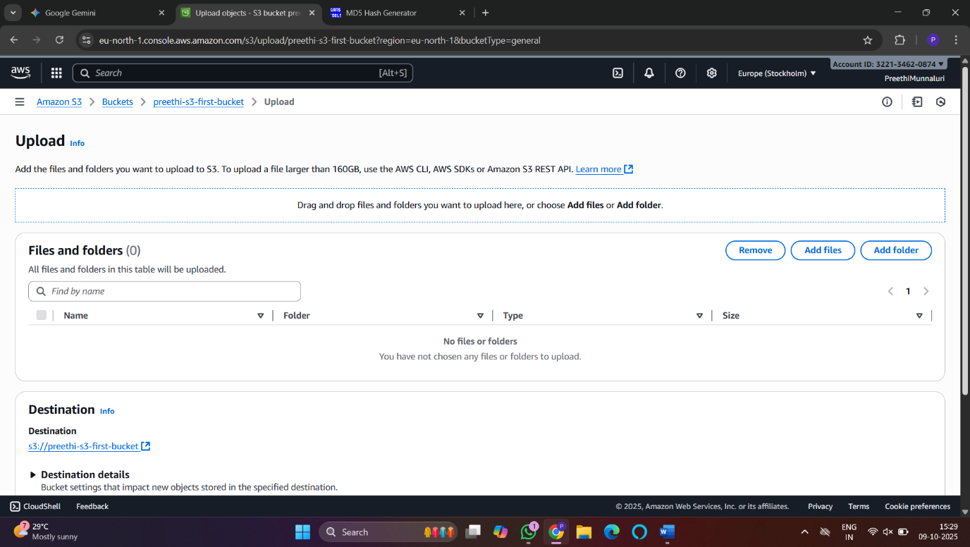
b. Delete the Bucket
Once the bucket is empty, you can delete it.
- In the Buckets list, select the now-empty bucket.
- Choose Delete.
- On the Delete bucket page, type the name of the bucket into the text field to confirm.
- Choose Delete bucket.

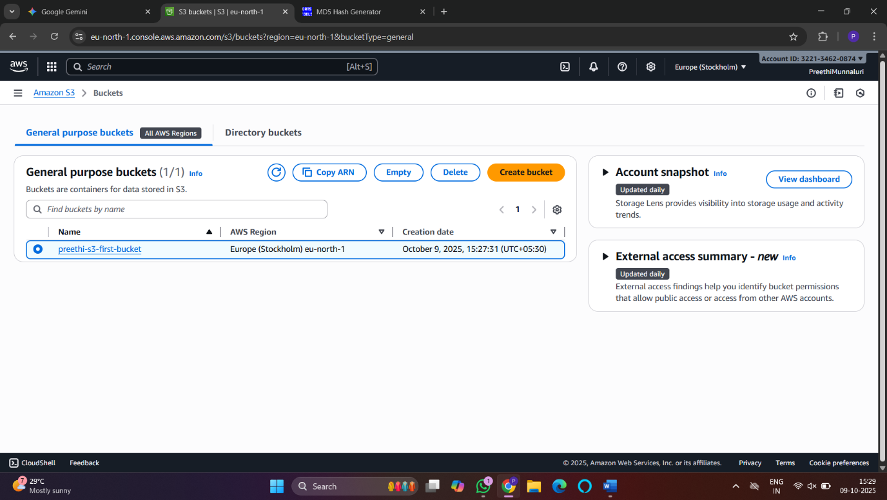

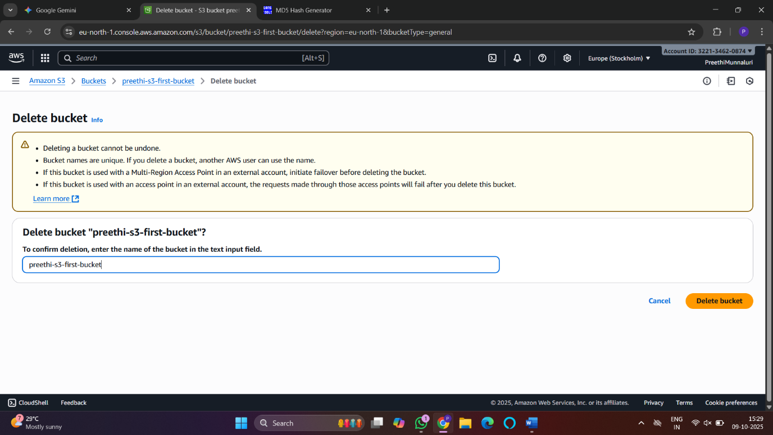
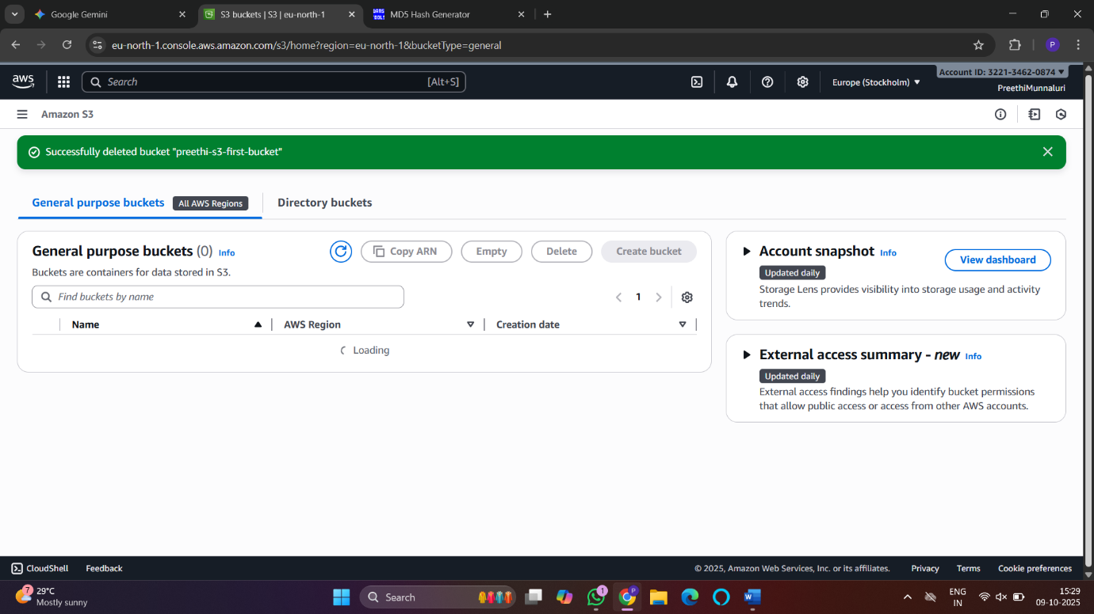

Google Cloud

Google Cloud Storage provides a static storage facility for storing and accessing objects on the Google Cloud Platform. An object is any kind of data, whether it is a file, image, video, etc. This system is infinitely scalable and can handle any size of data you produce. Let’s understand the concept in detail.

